A Level Art and Design Textiles

We are asking all students to complete some Independent Preparatory Work over the summer, before they join Year 12 in September. You will need to bring this work to lessons as the content will be assessed through introductory assessments which will be completed within the few first weeks of the new term.
Tasks
Task 1:
The first project you will be doing is all about Textures and looking at things ‘Up Close’. You will also be working mainly in a Monochrome colour palette so the main focus is on the textures and not the colours. If you are able to purchase a A4 spiral bound sketchbook, that would be excellent however if you are having any issues with this then please let us know. Places you can purchase one from are Amazon, Hobbycraft, The Range.
- Create a title page on the first page of your sketchbook. Please include a clear title of ‘Up Close Project’
- We would like you take 15-20 primary images of textures/objects up close. These could be outside, taking inspiration from nature, objects from around your house. If you are able to, please print your images and present them across a double page spread in your sketchbook.

If you need to contact a member of the department over the summer, please email Mrs Meader jmeader@littleheath.org.uk

Task 2: Paper manipulation inspiration

On A3 paper use Pintrest and other craft search engines for inspiration, create a white paper manipulation page demonstrating different ways of manipulating paper.

Watch https://www.youtube.com/watch?v=gqxvdqq82Pw for some more ideas about origami.

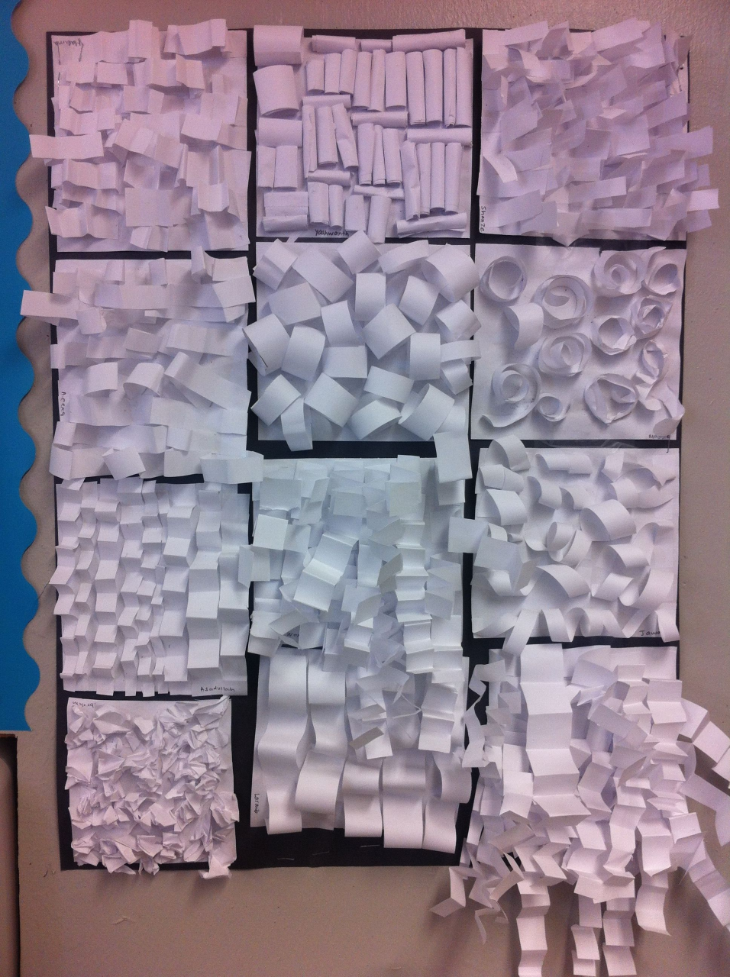
Extra reading
Choose two articles from some of the websites below. If there is another topic which interests you then feel free to read about this instead:
https://www.vam.ac.uk/collections/textiles
https://fashiontextilemuseum.org/whats-on/on-demand
FASHION NET | this is the world of fashion
Top 3 Textile Trends Transforming the UK Fashion World - Fibre2Fashion
Upcycling and the Textile Waste Problem — Simple Ecology
Best fabric manipulation techniques - La creative mama
Fashion by the Decades | Who What Wear UK
https://mymodernmet.com/contemporary-textile-art-history/
https://www.craftscouncil.org.uk/stories/textile-artist-bisa-butler-stitches-portraits-patchwork
Make some brief notes about the articles you read and what you found and how this interests you.

