A Level Pe

We are asking all students to complete some Independent Preparatory Work over the summer, before they join Year 12 in September. You will need to bring this work to lessons as the content will be assessed through introductory assessments which will be completed within the few first weeks of the new term.
Tasks
In order to prepare for this aspect of the course you will need to:
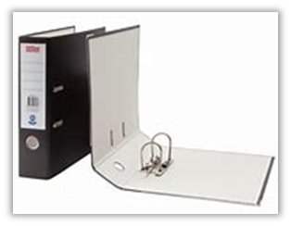
- We suggest you get yourself a large lever arch folder with separators for each topic (01, 02, 03, 04). You will be expected to bring your own paper to lessons and file away your notes appropriately.

1. Select 2 skills. Research and identify which muscles help to create movement for that skill. Think about what would be the agonist and antagonist.
2. Using the same skills, identify the articulating bones around the joints which provide those movements.
3. Research and learn the route of blood around the body. Try to include, names of key veins and arteries, as well as valves in the heart.
4. Research and learn definitions for:
1) heart rate
2) stroke volume
3) cardiac output,
4) minute ventilation
5) tidal volume
5. Describe the immediate effects on the cardiac system when exercising.
6. Describe the long term effects on the cardiac system due to exercise

Extra reading
- On X (twitter) follow OCR - our exam board. They often post relevant information relating to the topics we cover.
  - Other relevant to follow
    - : The Olympic games (@Olympics)
    - Team GB British Olympic Association (@TeamGB)
    - Sport England (@Sport_England)
- The Olympic website : https://olympics.com/
- Sport England Website : https://www.sportengland.org

